RAH NUTRITION PROGRAM IMPROVES HOSPITAL ATTENDANCE IN EASTERN NIGER

Access to healthcare in Eastern Niger is a real issue to the thousands of residents. Social and economic conditions in the region of Diffa, which are already extremely difficult, are exacerbated by brutal attacks targeting civilians and threats directed toward health workers and other government civil servants.

It’s a long way from the RAH warehouses in Raleigh, North Carolina to the Kirker Hospital in Niger, where rice-soy fortified packets ship to provide nutritious meals to patients in dire need. Just like in the arid countryside of Maine-Soroa in Niger, West Africa, many other health facilities in remote places in Africa and Latin America benefit from RAH support through the RAH feeding programs, thus improving the health and nutritional status of vulnerable people.

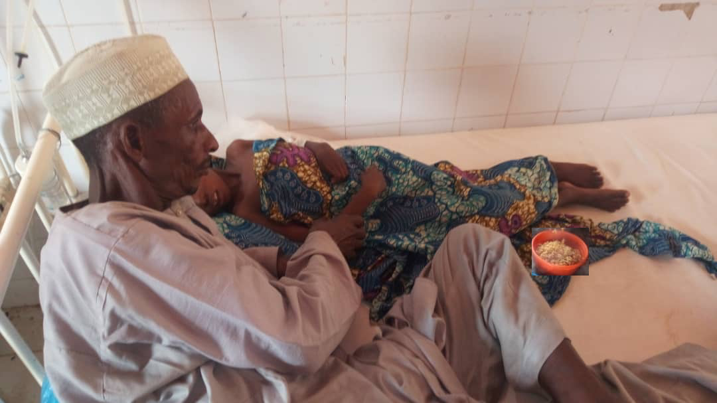
Djouma, a 12-year girl from Goujou, a village located at about 36 kilometers from Maine-Soroa recently fell sick and was cared for at Kirker Hospital. She was suffering from malaria and urinary infection.
During her entire hospital stay, she benefitted from the RAH food and life changing aid.

Her father, Malam Mani who was accompanying her during her treatment said that they couldn’t afford to come to the hospital each time they need medical attention. They only go when the situation becomes critical, “we had to sell one of the few goats we still own to be able to pay for transport and make it to the hospital. However, we were greatly relieved upon our arrival at Kirker Hospital when we found out that delicious hot meals were provided to patients and caregivers as well. Has it not been for this food assistance we would not have been be able to feed ourselves regularly”. Malam Mani further explained that generally when they come to the hospital, relatives living in Maine-Soroa bring them food the first day when they can afford it - - and then they are left with no assistance. He joyfully nods his head in appreciation of the support, “we are really grateful for that we are able to get such a wonderful meals each day.”
Djouma on her hospital bed, accompanied by her father receiving the RAH hot meal at lunchtime.

Like Malam Mani and his daughter Djouma, thousands of patients are benefitting from the RAH feeding program in Eastern Niger. Rise Against Hunger’s effort to end global hunger and malnutrition by building resilience, self-sufficiency and empowerment among the communities is undoubtedly making a difference in people’s life in Eastern Niger. The implementation of such feeding program greatly contributes to a healthier community in Eastern Niger as it improves hospital attendance by local communities and refugees alike.

